No. BSNLCO-TAXN/13(15)/1/2020-Taxation/4045 Dated:- 03-02-2021

To
The Chief General Managers and IFAs, All BSNL Circles/Units.

Sub:- TDS deduction on payment of medical bills of Retired Employees –Reg.

The undersigned is directed to inform you that, this office has received a PMOPG complaint filed by the BSNL Retired Executive Association addressed to Chairman CBDT regarding deduction of income tax (TDS) on medical bills of Retired Employees at the time posting in SAP.

In this connection, it is intimated that, the relevant extract of the Income Tax Act, 1961 related with the matter are as follows:-

“ As per Section 15 of the Income Tax Act,1961, the following income shall be chargeable to income-tax under the head “Salaries” u/s 15:-

- Any salary due from an employer or a former employer to an assesse in the previous year, whether paid or not;
- Any salary paid or allowed to him in the previous year by or on behalf of an employer or a former employer though not due or before it became due to him;
c).Any arrears of salary paid or allowed to him in the previous year by or on behalf of an employer or a former employer, if not charged to income-tax for any earlier previous year.

[Explanation 1]. For the removal of doubts, it is hereby declared that where any salary paid in advance is included in the total income of any person for any previous year it shall not be included again in the total income of the person when the salary becomes due.
[Explanation 2]. Any salary, bonus, commission or remuneration, by whatever name called, due to, or received by, a partner of a firm from the firm shall not be regarded as “salary” for the purpose of this section.
Further, as per Section 192 of the Income Tax Act, 1961, “Any person responsible for paying any income chargeable under the head “Salaries” shall, at the time of payment, deduct income- tax on the amount payable at the average rate of income tax computed on the basis of the rates in force for the financial year in which the payment is made, on the estimated income of the assesse under this head for that financial year.”
Further, as per Section 192, following conditions must be satisfied for applicability of Section 192:-
- Any payment is made by an employer to his employee.
- Such payment must be chargeable under the head ‘Salaries’.
- Quantum of such payments for the financial year in which such payments are made exceeds maximum amount not chargeable to tax (generally referred to as ‘threshold limit’).
Further, Tax is to be deducted at the time of payment of salary, i.e., tax is to be deducted at the time of ‘actual payment’ of salary. When the salary is only credited to the account of employee and is not actually paid to him, tax is not required to be deducted; tax will be deducted only at the time when salary is ‘actually’ paid to the employee.
In view of above, it has been decided by the Competent Authority to discontinue the existing practice of deducting TDS at the time of posting of medical bill in the SAP and deduct TDS on Retirees Medicals Bills at the time of payment with effect from January 2021 (i.e. Q4 of
F.Y. 2020-21) onwards.

This is for your kind information and necessary action please.

This may be treated as Most Urgent.

This issues with the approval of Sr. GM (Taxation).

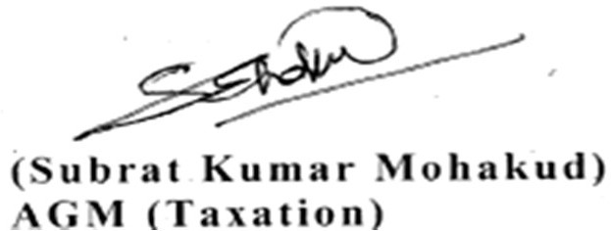

Copy to:-

- Sr. PPS to CMD- for kind information please.
- Sr. PPS to Director (Finance) - for kind information please.
- PGM (ERP), ALTTC Ghaziabad/ Sr. GM (CA/ERP-FICO) - for kind information and necessary action please.

-2-

